IMPORTANT NOTES REGARDING PLACEMENTS:

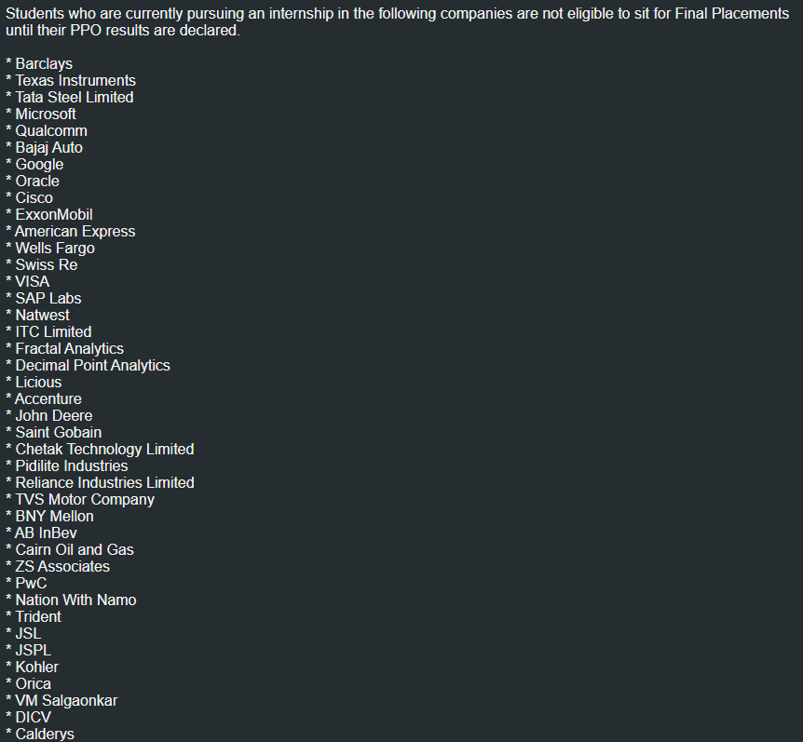



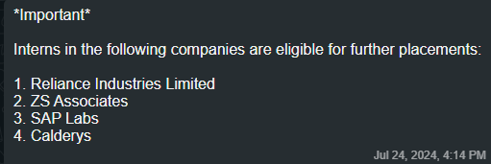

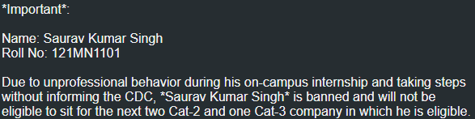

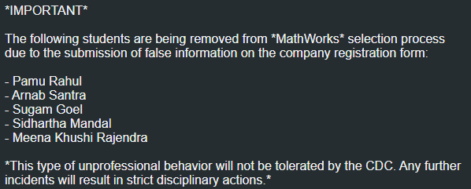

0 Selection Companies :

1. Increff
2. ProcDNA
3. BitGo
4. Licious SDE PPO Res.
5. Apple
6. Idrive
7. Sigmoid Analytics
8. WriteSonic
9. Atlas
10. Datoms(Embedded Software Engg.)
11. Leap
12. Infosys (Specialist Programmer)
13. Pubmatic

PSU’s :

1. BPCL

Female Only Companies :

1. Warner Bros. (Discovery Programme)
2. Tesco (Code Her challenge)
3. IBM Software Labs (M.tech Female only)

Bond :

1. Sigmoid Analytics (2yrs)
2. AiraMatrix (2Yrs)

Remote :

1. Quicksell
2. MPL (Immedieate Joining)
3. WriteSonic

Companies that revisited for different roles in Same year :

1. TCS :

1. NQT

2. Research & Innovation

1. IBM :
   1. Systems
   2. Software Labs
2. Siemens :
   1. EDA
   2. Healtineers
3. Searce Inc. :
   1. Software Roles (8)
   2. Analyst roles (3)
4. Infosys :
   1. Specialist Programmer
   2. Systems Engineer

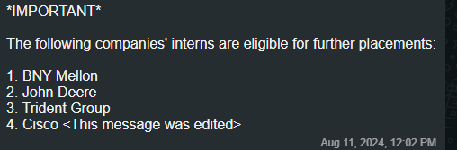

TCS ALLOWS 1 BACKLOG

BITGO REVISED THEIR CGPA FROM 7.5 TO 7

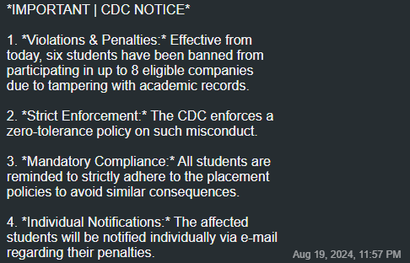

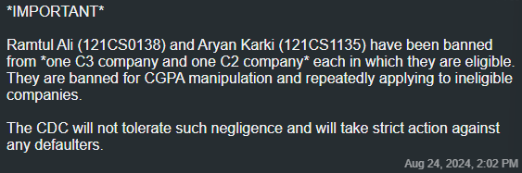

QuickSell Location : Remote (For the 6 Months Internship Period) ,after PPO Confirmation location will be Mumbai)

